Day 389 — Statistics & Probability for ML
Complete Revision Notes | Descriptive & Inferential Statistics • Probability Theory • Distributions • ML Mathematics
Learning goal: master core statistical and probabilistic concepts essential for machine learning: calculate and interpret measures of central tendency and dispersion, apply probability axioms, conditional probability, and Bayes' Theorem, characterize discrete and continuous distributions, compute covariance and correlation, evaluate statistical significance, and understand how loss functions, Naive Bayes, PCA, and maximum likelihood estimation rely on statistics.

1. Why Statistics & Probability in Machine Learning?
Machine learning is applied statistics at scale. At its core, every machine learning model attempts to estimate an unknown probability distribution or underlying function from a finite sample of noisy data.
Statistics provides the mathematical framework for data exploration, parameter estimation, regularization, hypothesis testing, model evaluation, and quantifying uncertainty in predictions.
Statistical Concept | Role in Machine Learning | Concrete ML Application
Central Tendency & Variance | Feature understanding, baseline models, normalization | Z-score scaling (StandardScaler), Zero-R classifier
Bayes' Theorem | Inversion of conditional probabilities with prior beliefs | Naive Bayes classification, Bayesian Optimization, MAP estimation
Probability Distributions | Modeling feature generation, priors, and residuals | Gaussian assumptions in GDA/LDA, Bernoulli in binary cross-entropy
Covariance & Correlation | Identifying multicollinearity and variance directions | Principal Component Analysis (PCA), feature selection
Central Limit Theorem | Foundation for sampling, bootstrap, and hypothesis tests | Confidence intervals for model metrics, cross-validation stability
Maximum Likelihood (MLE) | Parameter optimization framework for loss functions | Deriving Mean Squared Error (MSE) and Log-Loss

Descriptive vs. Inferential Statistics
Category | Definition & Objectives | Common Techniques & Outputs
Descriptive Statistics | Summarizes, organizes, and describes observed sample properties without making broader claims | Mean, median, mode, variance, standard deviation, IQR, histograms, boxplots
Inferential Statistics | Draws conclusions, makes predictions, and tests hypotheses about an unobserved population from sample data | Hypothesis testing (p-values, t-tests, ANOVA), confidence intervals, regression estimation

2. Measures of Central Tendency & Distribution Skewness
Measures of central tendency locate the center or typical value of a numerical distribution. The three primary metrics—Mean, Median, and Mode—behave differently depending on distribution shape and the presence of outliers.
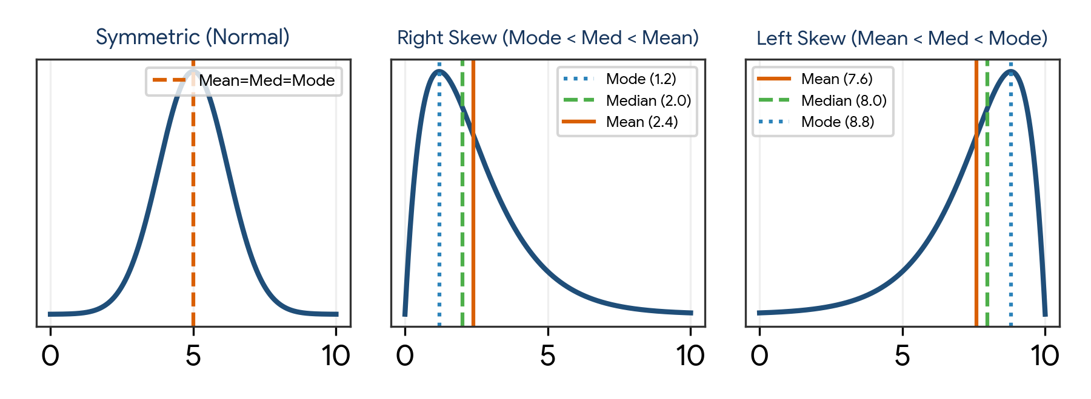
Figure 1. Relative positions of Mean, Median, and Mode across Symmetric, Right-Skewed, and Left-Skewed distributions.
Measure | Mathematical Formula | Properties & Sensitivity | Best Used When
Mean (Arithmetic Average) | μ = (Σ x_i) / N or x̄ = (Σ x_i) / n | Uses all values; highly sensitive to extreme outliers and heavy skew | Data is roughly symmetric with no extreme outliers
Median (50th Percentile) | Middle value of sorted data: x_((n+1)/2) | Resistant (robust) to outliers; divides sample into equal halves | Data is skewed or contains extreme values (e.g., salary, house price)
Mode (Most Frequent) | arg max_x (Frequency(x)) | Works on numerical and categorical features; may be unimodal or multimodal | Categorical data or discrete counts with dominant classes

Distribution skewness and central tendency relationships
Distribution Shape | Ordering of Metrics | Typical Data Examples | Machine Learning Impact
Symmetric (Normal) | Mean ≈ Median ≈ Mode | Height, measurement errors, test scores | Ideal for linear regression, Gaussian Naive Bayes, Z-score scaling
Positive Skew (Right-skewed) | Mode < Median < Mean | Income, healthcare costs, e-commerce order values | Long right tail drags mean upward; requires log1p or Box-Cox transform
Negative Skew (Left-skewed) | Mean < Median < Mode | Age at retirement, easy exam scores, gestation time | Long left tail drags mean downward; requires power or reflection transforms

Computing central tendency in Python
import numpy as np
import pandas as pd
from scipy import stats

data = [45, 52, 55, 60, 62, 65, 68, 70, 72, 75, 250] # 250 is an outlier

mean_val = np.mean(data)
median_val = np.median(data)
mode_val = stats.mode(data, keepdims=True).mode[0]
skew_val = stats.skew(data)

print(f"Mean: {mean_val:.2f}") # 79.45 (distorted by 250)
print(f"Median: {median_val:.2f}") # 65.00 (robust to 250)
print(f"Mode: {mode_val:.2f}") # 45.00
print(f"Skew: {skew_val:.2f}") # +2.61 (strongly right-skewed)

3. Measures of Dispersion & Variance
Measures of dispersion quantify the spread, scatter, or variability of data points around their central value. Knowing the average value is useless without knowing whether individual observations lie tightly clustered around it or spread widely across the scale.
Measure | Mathematical Formula | Units & Interpretation
Range | Maximum − Minimum | Same units as data; crude measure sensitive only to extremes
Interquartile Range (IQR) | IQR = Q3 − Q1 (75th percentile − 25th percentile) | Same units as data; middle 50% spread; robust against outliers
Population Variance (σ²) | σ² = (1 / N) × Σ (x_i − μ)² | Squared units of data; penalizes large deviations quadratically
Sample Variance (s²) | s² = [1 / (n − 1)] × Σ (x_i − x̄)² | Squared units; uses Bessel's correction (n − 1) for unbiased estimation
Standard Deviation (s) | s = sqrt(s²) | Original units of data; direct average distance of observations from the mean
Coefficient of Variation (CV) | CV = (s / x̄) × 100% | Dimensionless percentage; compares relative variability across different units

Bessel's correction: Why divide sample variance by (n − 1)?
When estimating population variance from a sample, sample deviations are calculated from the sample mean (x̄), not the true population mean (μ). Because the sample mean is itself calculated from the sample, sample points lie naturally closer to x̄ than to μ, systematically underestimating true variance. Dividing by (n − 1) instead of n corrects this downward bias, producing an unbiased estimator.

The Empirical Rule (68–95–99.7%)
For any unimodal, roughly bell-shaped (Gaussian) distribution, the Empirical Rule describes how observations are distributed across standard deviations from the mean.
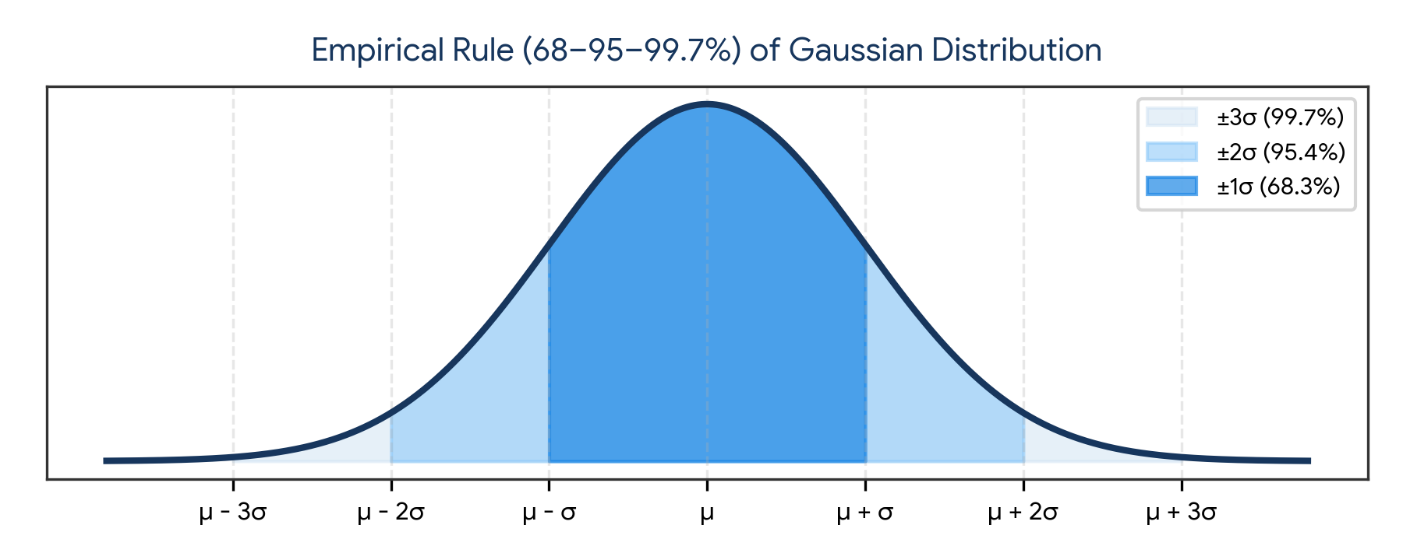
Figure 2. Empirical Rule: 68.3%, 95.4%, and 99.7% confidence regions in a Gaussian distribution.
Standard Deviation Interval | Enclosed Percentage of Data | Z-Score Boundary | Practical Utility in ML
μ ± 1σ | Approximately 68.3% | −1.0 ≤ z ≤ +1.0 | Core density region for standard observations
μ ± 2σ | Approximately 95.4% | −2.0 ≤ z ≤ +2.0 | Standard 95% confidence interval for hypothesis testing
μ ± 3σ | Approximately 99.7% | −3.0 ≤ z ≤ +3.0 | Outlier detection rule: flag values beyond |z| > 3.0 (< 0.3% chance)

4. Probability Theory & Fundamental Axioms
Probability measures the likelihood that an uncertain event occurs on a scale from 0 (impossible) to 1 (certain).

Kolmogorov's three probability axioms
Axiom | Mathematical Statement | Meaning
1. Non-negativity | P(E) ≥ 0 for all events E | The probability of any event is a non-negative real number
2. Unit Measure | P(S) = 1, where S is sample space | Some outcome in the entire sample space is guaranteed to occur
3. Additivity | P(A ∪ B) = P(A) + P(B) if A ∩ B = ∅ | Probabilities of mutually exclusive events sum directly together

Types of probability & set operations
Concept | Formula / Rule | Definition & Example
Marginal Probability | P(A) | Unconditional probability of a single event A regardless of others
Joint Probability | P(A ∩ B) = P(A, B) | Probability that both events A and B occur simultaneously
Union (Addition Rule) | P(A ∪ B) = P(A) + P(B) − P(A ∩ B) | Probability that event A or event B (or both) occurs
Complement Rule | P(A') = 1 − P(A) | Probability that event A does NOT occur
Independent Events | P(A ∩ B) = P(A) × P(B) | Occurrence of event A provides zero information about event B

5. Conditional Probability & Bayes' Theorem in ML
Conditional probability evaluates the probability of an event A occurring given that event B has already occurred: P(A | B) = P(A ∩ B) / P(B), provided P(B) > 0.
Bayes' Theorem provides the mathematical bridge to invert conditional probabilities, allowing us to update prior beliefs about model hypotheses in light of observed evidence.

Bayes' Theorem mathematical formulation
Bayes' Rule:
P(Evidence | Hypothesis) * P(Hypothesis)
P(Hypothesis | Evidence) = ----------------------------------------
P(Evidence)

Posterior = (Likelihood * Prior) / Marginal Evidence

Where:
- P(H | E) = Posterior probability (belief after seeing data)
- P(E | H) = Likelihood of observing evidence E given hypothesis H
- P(H) = Prior probability (initial belief before seeing data)
- P(E) = Marginal evidence: Σ P(E | H_i) * P(H_i) (normalizing constant)

How Bayes' Theorem powers Naive Bayes Classification
In supervised classification, given a feature vector x = (x_1, x_2, ..., x_d), we predict the class C_k that maximizes P(C_k | x):
P(C_k | x_1, ..., x_d) ∝ P(C_k) * ∏ [i=1 to d] P(x_i | C_k)

The 'naive' conditional independence assumption states that all features x_i are conditionally independent given the class label C_k. While rarely strictly true in real-world data, Naive Bayes performs surprisingly well for high-dimensional text classification (spam detection, sentiment analysis) and serves as an ultra-fast baseline.

Bayesian inference example in Python
# Medical diagnosis example:
# Disease prevalence (Prior): P(D) = 0.01 (1% of population)
# Test Sensitivity: P(Pos | D) = 0.95 (95% true positive rate)
# Test False Positive: P(Pos | Healthy) = 0.05 (5% false positive rate)

prior_D = 0.01
prior_H = 0.99
p_pos_given_D = 0.95
p_pos_given_H = 0.05

# Marginal probability of testing positive: P(Pos)
p_pos = (p_pos_given_D * prior_D) + (p_pos_given_H * prior_H)

# Posterior: P(D | Pos)
posterior_D_given_pos = (p_pos_given_D * prior_D) / p_pos

print(f"P(Positive Test) = {p_pos:.4f}") # 0.0590
print(f"P(Disease | Positive Test) = {posterior_D_given_pos:.4f}") # 0.1610 (16.1%)
# Counter-intuitive: Even with 95% accuracy, low prior disease prevalence means
# an individual testing positive has only a 16.1% chance of actually having the disease!

6. Probability Distributions in Machine Learning
A random variable maps outcomes of random phenomena to real numbers. Discrete random variables take countable values and are described by a Probability Mass Function (PMF). Continuous random variables take uncountably infinite values and are described by a Probability Density Function (PDF).
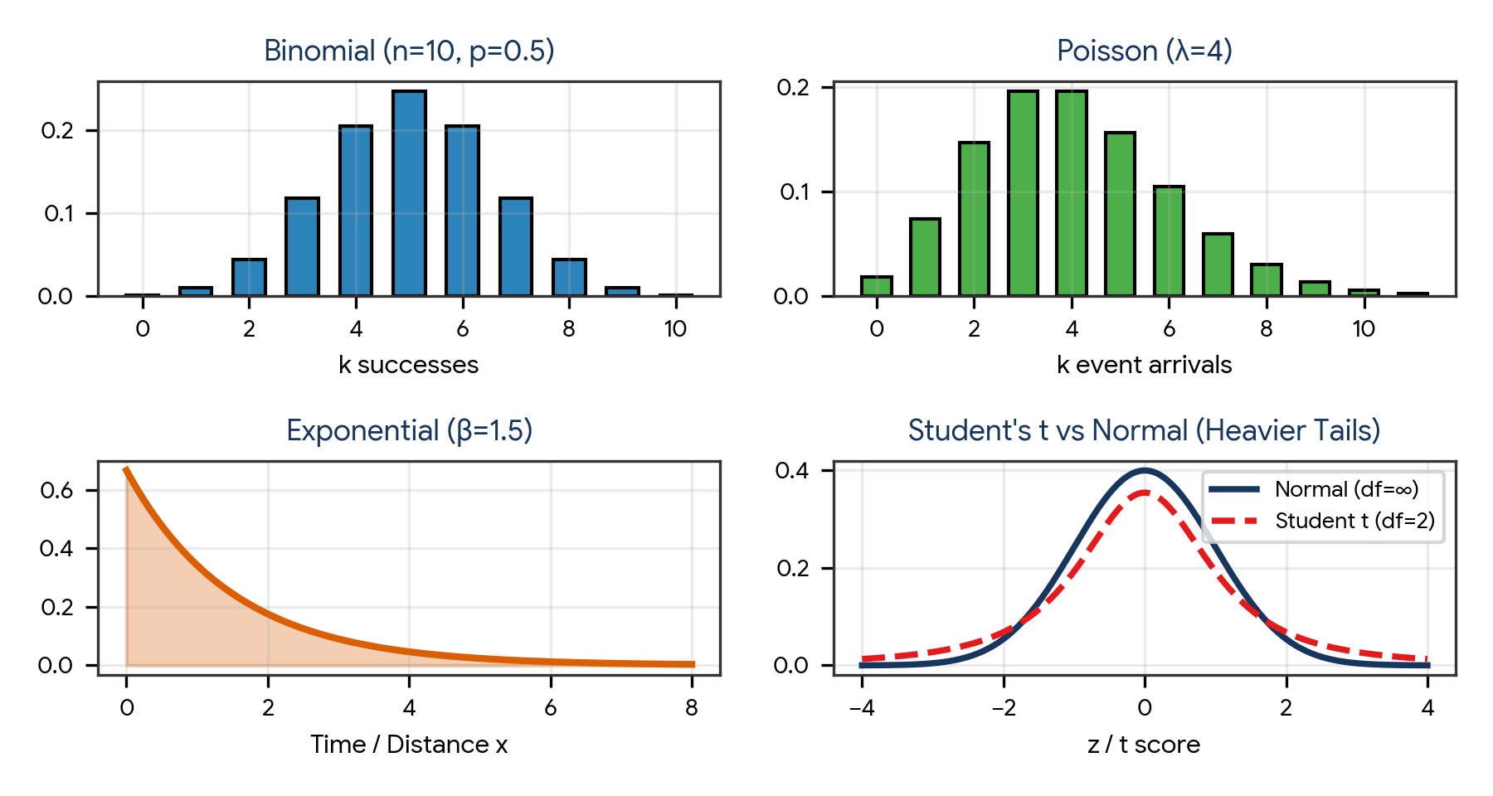
Figure 3. Common probability distributions: Discrete Binomial and Poisson; Continuous Exponential and Student's t vs Normal.
Distribution | Type | Key Parameters | ML Use Case
Bernoulli | Discrete | p (success probability) | Binary classification targets (0 or 1), logistic regression loss
Binomial | Discrete | n (trials), p (probability) | A/B testing click-through rates, conversion modeling
Categorical / Multinomial | Discrete | K (categories), p_1...p_K | Multi-class classification, softmax output layer, NLP token sampling
Poisson | Discrete | λ (arrival rate) | Modeling website traffic, server requests, count-based target regression
Uniform | Continuous / Discrete | a (min), b (max) | Random search hyperparameter tuning, weight initialization (Xavier/He)
Normal (Gaussian) | Continuous | μ (mean), σ² (variance) | Linear regression residuals, Gaussian Naive Bayes, PCA, VAE latent space
Student's t | Continuous | df (degrees of freedom) | Hypothesis testing on small sample sizes (n < 30), robust regression
Exponential | Continuous | λ (decay rate) | Time-to-failure modeling, survival analysis, customer churn modeling
Log-Normal | Continuous | μ, σ (log scale) | Income distributions, latency times, financial portfolio returns

7. Covariance, Correlation & Multicollinearity
Covariance measures the directional relationship between two random variables. Correlation standardizes covariance by dividing by standard deviations, producing a scale-free metric bounded between −1.0 and +1.0.
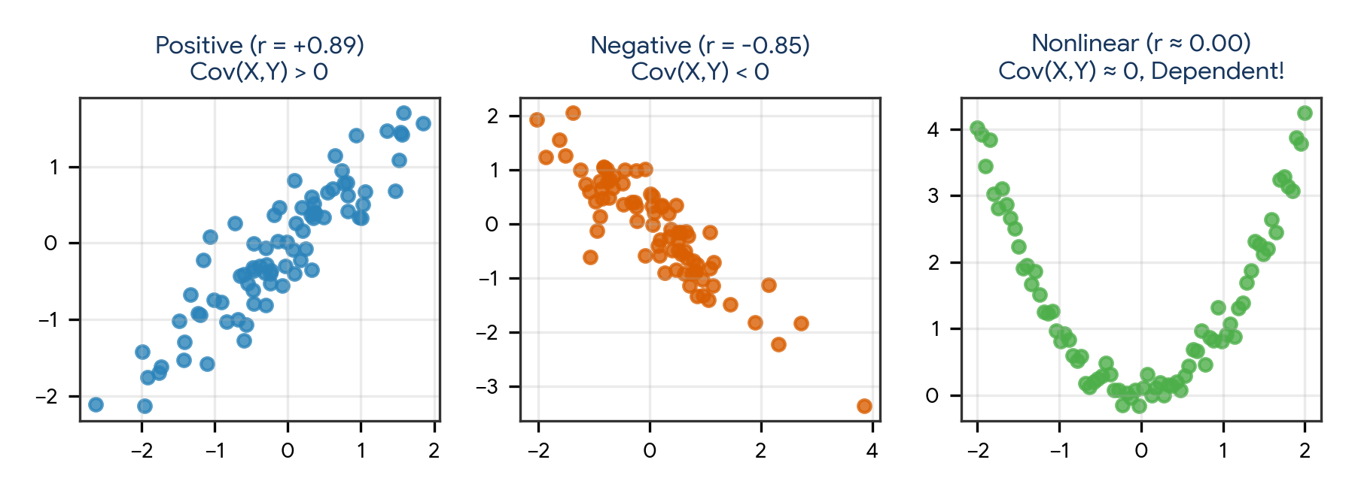
Figure 4. Scatter plots showing Positive, Negative, and Nonlinear Zero-Correlation relationships.
Metric | Mathematical Formula | Range & Scale | Interpretation & Caveats
Covariance: Cov(X, Y) | (1 / n) Σ (x_i − x̄)(y_i − ȳ) | −∞ to +∞ (depends on data units) | Sign indicates direction (+ or −); magnitude is uninterpretable across scales
Pearson Correlation (r) | Cov(X, Y) / (s_X × s_Y) | −1.0 to +1.0 (dimensionless) | Measures strictly linear association; sensitive to outliers
Spearman Rank (ρ) | 1 − [6 Σ d_i² / (n(n² − 1))] | −1.0 to +1.0 (dimensionless) | Measures monotonic association; robust to outliers and skewed distributions
Cramér's V | sqrt( χ² / (n × min(k−1, r−1)) ) | 0.0 to 1.0 | Measures association between two nominal categorical variables

Critical warning: Correlation does NOT imply causation
A high correlation between X and Y indicates that their values co-vary, but does not prove that X causes Y. Common pitfalls include:
- Confounding Variables: An unobserved third factor Z drives both X and Y (e.g., ice cream sales and drowning rates both increase due to summer heat).
- Spurious Correlations: Coincidental alignment in finite time-series datasets.
- Reverse Causality: Y actually causes X rather than X causing Y.

Computing covariance and correlation matrices in Python
import numpy as np
import pandas as pd

np.random.seed(42)
x = np.random.normal(50, 10, 100)
y = 1.8 * x + np.random.normal(0, 8, 100)
z = np.random.uniform(10, 100, 100)

df = pd.DataFrame({"Age": x, "Salary": y, "Random_Noise": z})

print("Covariance Matrix:")
print(df.cov().round(2))

print("\nPearson Correlation Matrix:")
print(df.corr(method="pearson").round(2))

print("\nSpearman Monotonic Correlation Matrix:")
print(df.corr(method="spearman").round(2))

8. Sampling & The Central Limit Theorem (CLT)
The Central Limit Theorem (CLT) is among the most profound results in probability theory: regardless of the underlying population distribution (uniform, exponential, bimodal), the distribution of sample means approaches a Normal (Gaussian) distribution as sample size n grows (typically n ≥ 30).
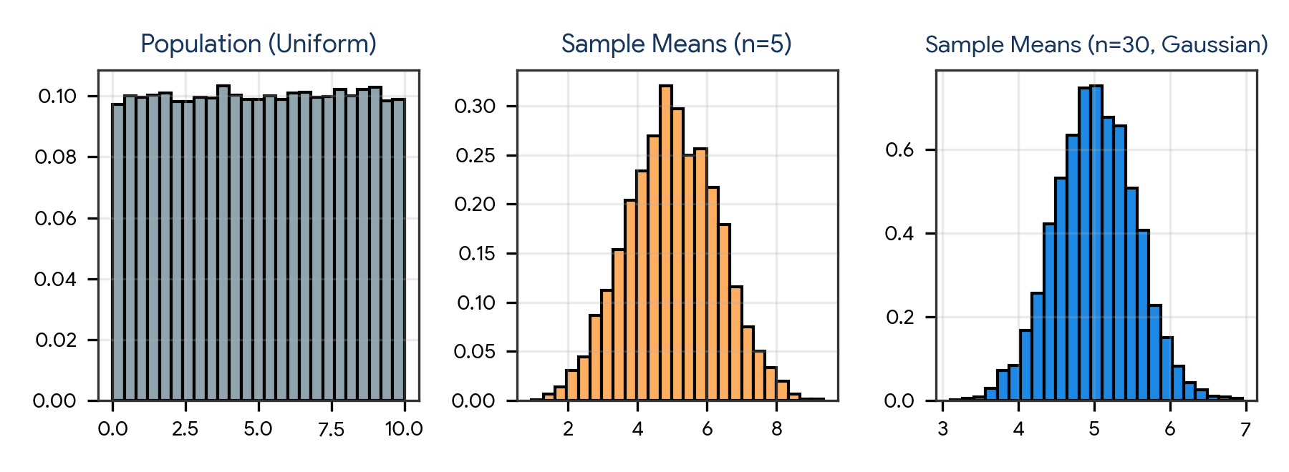
Figure 5. Central Limit Theorem: Even from a flat uniform population, sample means become bell-shaped as n increases.
Property | Population Parameter | Sample Mean Distribution (Sampling Distribution)
Mean | μ | μ_x̄ = μ (Expected value of sample mean equals population mean)
Variance | σ² | σ²_x̄ = σ² / n (Variance shrinks linearly with sample size n)
Standard Error (SE) | σ | SE = σ / sqrt(n) (Uncertainty of sample mean shrinks with sqrt(n))

Why CLT is indispensable in Machine Learning
- Confidence intervals: Allows construction of margin-of-error bounds around cross-validation performance metrics (e.g., test accuracy ± 1.96 × SE).
- Residual modeling: In linear regression, error terms represent the sum of many minor unobserved factors; by the CLT, their combined effect tends toward a Gaussian distribution.
- A/B Testing: Conversion metrics across thousands of visitors converge to normality, enabling standard z-tests and t-tests.

9. Hypothesis Testing & Statistical Significance
Hypothesis testing is an inferential procedure that evaluates two mutually exclusive statements about a population to determine which statement is best supported by sample data.
Hypothesis Concept | Notation / Formula | Definition
Null Hypothesis (H₀) | H₀: μ₁ = μ₂ (or θ = 0) | Status quo assumption: no effect, no difference, or no association
Alternative Hypothesis (H₁) | H₁: μ₁ ≠ μ₂ (or θ > 0) | Research claim: a statistically significant effect or difference exists
Significance Level (α) | Typically α = 0.05 (or 0.01) | Maximum acceptable probability of committing a Type I error
p-value | P(Data as extreme as observed | H₀ is true) | Probability of obtaining observed results by pure chance if H₀ holds
Decision Rule | Reject H₀ if p-value ≤ α | If p-value is tiny, observed data is extremely unlikely under H₀

Type I vs. Type II Errors
True Reality | Decision: Fail to Reject H₀ | Decision: Reject H₀ (Claim Discovery)
H₀ is True (No Real Effect) | Correct Decision (True Negative, 1 − α) | Type I Error (False Positive, False Discovery, Rate = α)
H₀ is False (Real Effect Exists) | Type II Error (False Negative, Missed Discovery, Rate = β) | Correct Decision (Power of Test, True Positive, 1 − β)

Common statistical hypothesis tests in ML
Test Name | Null Hypothesis (H₀) | When to Use in Data Science
One-Sample t-test | Sample mean equals population baseline μ₀ | Validate if model inference latency exceeds SLA threshold
Independent Two-Sample t-test | Means of two independent groups are equal (μ₁ = μ₂) | A/B testing comparing mean revenue per user between variants
Paired t-test | Mean difference between paired samples equals zero | Comparing accuracy of Model A vs Model B on the exact same cross-validation folds
ANOVA (F-test) | Means of three or more groups are equal (μ₁ = μ₂ = ... = μ_k) | Comparing performance across multiple hyperparameter configurations
Chi-Square Test (χ²) | Two categorical variables are independent | Feature selection: test if a categorical feature correlates with target class

10. Statistical Foundations of Machine Learning Algorithms
Machine learning algorithms are formal operationalizations of statistical estimation theories. Understanding their probabilistic roots clarifies their optimization objectives and hyperparameter behaviors.
ML Algorithm | Foundational Statistical Framework | Statistical Mechanism in Action
Linear Regression | Maximum Likelihood Estimation (MLE) under Gaussian noise | Minimizing Mean Squared Error (MSE) is mathematically identical to maximizing log-likelihood when errors ε ~ N(0, σ²)
Logistic Regression | MLE under Bernoulli distribution (Log-Loss / Cross-Entropy) | Maximizes the joint Bernoulli likelihood of observed class labels using the sigmoid function: P(y=1|x) = 1 / (1 + e^(−z))
Naive Bayes | Bayes' Theorem with conditional feature independence | Computes posterior class probabilities using class priors P(C) and feature likelihoods P(x_i | C)
Ridge / Lasso Regression | Maximum A Posteriori (MAP) Estimation with Priors | L2 (Ridge) corresponds to Gaussian prior on weights; L1 (Lasso) corresponds to Laplace prior enforcing sparsity
K-Means Clustering | Expectation-Maximization (EM) on Gaussian Mixture Models | Hard-assignment special case of GMM where all cluster covariance matrices are isotropic and equal (σ²I)
Principal Component Analysis | Eigen-decomposition of Sample Covariance Matrix | Finds orthogonal axes that maximize projected variance (eigenvectors of data covariance matrix Σ)

11. Practical Project — Statistical Validation & Diagnostic Suite
Objective: build an automated, modular Python class that accepts raw numerical features, computes complete descriptive statistics, verifies normality via the Shapiro-Wilk test, calculates covariance and Pearson/Spearman correlation matrices, executes a two-sample hypothesis test comparing group performance, and generates diagnostic visualization reports.

Project structure
statistical_validation_suite/
|
|-- data/
| |-- ab_test_results.csv
|
|-- reports/
| |-- distributions.png
| |-- correlation_matrix.png
| |-- statistical_summary.csv
|
|-- main.py
|-- requirements.txt

requirements.txt
numpy
pandas
scipy
matplotlib
seaborn

Complete main.py
import os
import numpy as np
import pandas as pd
from scipy import stats
import matplotlib.pyplot as plt
import seaborn as sns

class StatisticalDiagnosticEngine:
def __init__(self, data_dict):
self.df = pd.DataFrame(data_dict)
self.output_dir = "reports"
os.makedirs(self.output_dir, exist_ok=True)
sns.set_theme(style="whitegrid")

def descriptive_summary(self):
print("=== 1. COMPREHENSIVE DESCRIPTIVE STATISTICS ===")
summary_records = []
for col in self.df.select_dtypes(include=np.number).columns:
s = self.df[col].dropna()
mean = s.mean()
median = s.median()
mode = s.mode()[0]
var = s.var(ddof=1)
std = s.std(ddof=1)
iqr = s.quantile(0.75) - s.quantile(0.25)
skew = s.skew()
kurt = s.kurt()

# Normality test (Shapiro-Wilk)
stat, p_val = stats.shapiro(s)

summary_records.append({
"Feature": col,
"Count": len(s),
"Mean": round(mean, 2),
"Median": round(median, 2),
"Mode": round(mode, 2),
"Std_Dev": round(std, 2),
"Variance": round(var, 2),
"IQR": round(iqr, 2),
"Skewness": round(skew, 2),
"Kurtosis": round(kurt, 2),
"Shapiro_p_value": round(p_val, 4),
"Is_Gaussian": "Yes" if p_val > 0.05 else "No"
})

summary_df = pd.DataFrame(summary_records)
print(summary_df.to_string(index=False))
summary_df.to_csv(os.path.join(self.output_dir, "statistical_summary.csv"), index=False)
return summary_df

def correlation_and_covariance_analysis(self):
print("\n=== 2. COVARIANCE & CORRELATION ANALYSIS ===")
numeric_df = self.df.select_dtypes(include=np.number)
cov_matrix = numeric_df.cov()
corr_pearson = numeric_df.corr(method="pearson")
corr_spearman = numeric_df.corr(method="spearman")

print("Covariance Matrix:\n", cov_matrix.round(2))
print("\nPearson Correlation (Linear):\n", corr_pearson.round(2))
print("\nSpearman Correlation (Monotonic):\n", corr_spearman.round(2))

fig, ax = plt.subplots(figsize=(6, 5))
sns.heatmap(corr_pearson, annot=True, cmap="coolwarm", fmt=".2f", vmin=-1, vmax=1, ax=ax)
ax.set_title("Pearson Correlation Heatmap")
plt.tight_layout()
plt.savefig(os.path.join(self.output_dir, "correlation_matrix.png"), dpi=300)
plt.close()

def compare_groups_hypothesis_test(self, group_col, value_col):
print(f"\n=== 3. HYPOTHESIS TEST: A/B TESTING ON {value_col} BY {group_col} ===")
groups = self.df[group_col].unique()
if len(groups) != 2:
print("Hypothesis test requires exactly 2 distinct groups.")
return

g1 = self.df[self.df[group_col] == groups[0]][value_col].dropna()
g2 = self.df[self.df[group_col] == groups[1]][value_col].dropna()

# Two-sample t-test (Welch's t-test: does not assume equal variances)
t_stat, p_val = stats.ttest_ind(g1, g2, equal_var=False)

print(f"Group '{groups[0]}': N={len(g1)}, Mean={g1.mean():.2f}, Std={g1.std():.2f}")
print(f"Group '{groups[1]}': N={len(g2)}, Mean={g2.mean():.2f}, Std={g2.std():.2f}")
print(f"Welch's t-statistic: {t_stat:.4f}")
print(f"p-value: {p_val:.4f}")

alpha = 0.05
if p_val < alpha:
print(f"RESULT: Reject H₀ at α={alpha}. Statistically significant difference exists.")
else:
print(f"RESULT: Fail to reject H₀ at α={alpha}. Insufficient evidence of difference.")

def run(self):
self.descriptive_summary()
self.correlation_and_covariance_analysis()
self.compare_groups_hypothesis_test("Variant", "Conversion_Value")
print("\nDiagnostic reports and plots saved to /reports folder.")

if __name__ == "__main__":
np.random.seed(42)
sample_size = 200

# Simulate e-commerce A/B test data
variant = np.random.choice(["Control_A", "Treatment_B"], size=sample_size)
base_val = np.random.normal(50, 12, size=sample_size)
# Treatment adds positive lift
conversion = np.where(variant == "Treatment_B", base_val + 5.5, base_val)
page_time = conversion * 1.4 + np.random.normal(0, 5, size=sample_size)

test_data = {
"Variant": variant,
"Conversion_Value": conversion,
"Page_Time_Seconds": page_time
}

engine = StatisticalDiagnosticEngine(test_data)
engine.run()

Run the project
pip install -r requirements.txt
python main.py

Expected generated outputs
reports/
|-- distributions.png
|-- correlation_matrix.png
|-- statistical_summary.csv

Project notes: using Welch's t-test (equal_var=False) is best practice in real-world ML testing because variants rarely have identical variances. Combining the Shapiro-Wilk test for normality with parametric and non-parametric tests ensures proper statistical rigor.

12. Common Statistical Mistakes to Avoid in ML
- Confusing correlation with causation: asserting that optimizing a strongly correlated feature will directly cause the target variable to move.
- Relying exclusively on the mean for skewed data: reporting average income or latency without checking the median or percentiles (p50, p95, p99).
- p-hacking and multiple testing: repeatedly slicing datasets until a p-value falls below 0.05 by random chance without applying Bonferroni correction.
- Assuming zero correlation means variables are independent: Pearson r only detects linear relationships; variables with quadratic relationships (y = x²) have r ≈ 0 but are perfectly dependent.
- Confusing Type I and Type II errors: failing to balance false positive costs vs false negative costs in clinical or fraud detection models.
- Ignoring sample size in Central Limit Theorem: applying Gaussian parametric tests to heavily skewed distributions when sample size is very small (n < 20).
- Forgetting Bessel's correction: computing sample variance with 1/n instead of 1/(n − 1), introducing negative bias into variance estimates.

13. Quick Revision — Key Differences
Comparison | First Concept | Second Concept
Mean vs Median | Arithmetic average; sensitive to extreme outliers | 50th percentile midpoint; robust to outliers and skewness
Variance vs Standard Deviation | Average squared deviation (units²); used in algebra | Square root of variance (original units); directly interpretable
Covariance vs Correlation | Unstandardized directional measure; scale-dependent | Standardized scale-free measure bounded between −1.0 and +1.0
PMF vs PDF | Probability Mass Function for discrete outcomes; P(X = x) > 0 | Probability Density Function for continuous variables; P(X = x) = 0
Type I Error vs Type II Error | False Positive: rejecting a true null hypothesis (α) | False Negative: failing to reject a false null hypothesis (β)
Parametric vs Non-parametric Tests | Assumes specific underlying distribution (e.g., Gaussian) | Distribution-free; relies on ranks or permutations
MLE vs MAP | Finds parameters maximizing data likelihood P(D|θ) | Finds parameters maximizing posterior P(θ|D) incorporating prior P(θ)

14. Important Formulas & Mathematical Cheat Sheet
Concept | Formula / Definition
Sample Mean | x̄ = (1 / n) × Σ x_i
Sample Variance (Unbiased) | s² = [1 / (n − 1)] × Σ (x_i − x̄)²
Sample Standard Deviation | s = sqrt(s²)
Standard Error of the Mean | SE = s / sqrt(n)
Z-Score Standardization | z = (x − μ) / σ
Conditional Probability | P(A | B) = P(A ∩ B) / P(B)
Bayes' Theorem | P(A | B) = [P(B | A) × P(A)] / P(B)
Sample Covariance | Cov(X, Y) = [1 / (n − 1)] × Σ (x_i − x̄)(y_i − ȳ)
Pearson Correlation Coefficient | r = Cov(X, Y) / (s_X × s_Y)
Independent Two-Sample t-statistic | t = (x̄₁ − x̄₂) / sqrt( s₁²/n₁ + s₂²/n₂ )
Two-Event Union | P(A ∪ B) = P(A) + P(B) − P(A ∩ B)
Log-Loss (Binary Cross-Entropy) | Loss = − [ y log(p) + (1 − y) log(1 − p) ]

15. Interview / Viva Questions
What is the difference between mean, median, and mode?
The mean is the arithmetic average (sensitive to outliers), the median is the 50th percentile middle value (robust to outliers), and the mode is the most frequently occurring value.
Why is the median preferred over the mean for skewed data?
Because extreme values in the tail pull the mean toward the skew, while the median remains anchored at the true middle observation.
What is Bessel's correction and why is it used?
Dividing sample variance by (n − 1) instead of n corrects the negative bias that occurs when sample deviations are measured from the sample mean rather than the population mean.
Explain the Empirical Rule of a Normal distribution.
For bell-shaped Gaussian distributions, approximately 68.3% of data lies within μ ± 1σ, 95.4% within μ ± 2σ, and 99.7% within μ ± 3σ.
State Bayes' Theorem and explain its components.
P(A|B) = [P(B|A) × P(A)] / P(B). P(A|B) is the posterior, P(B|A) is the likelihood, P(A) is the prior belief, and P(B) is the marginal evidence.
Why is Naive Bayes called 'naive'?
Because it naively assumes that all predictor features are conditionally independent given the target class label, which is rarely true in reality.
What is the difference between discrete and continuous probability distributions?
Discrete distributions describe countable variables using a PMF where P(X = x) has non-zero mass; continuous distributions describe uncountably infinite values using a PDF where probability is measured over intervals.
What is the difference between covariance and correlation?
Covariance indicates the direction of linear association but is scale-dependent; correlation standardizes covariance by dividing by standard deviations, producing a scale-free metric between −1.0 and +1.0.
Can two variables have zero correlation but still be strongly dependent?
Yes. Pearson correlation strictly measures linear association. If y = x², the correlation is zero, yet y is perfectly dependent on x.
What does the Central Limit Theorem state?
As sample size n increases (typically n ≥ 30), the distribution of sample means approaches a Normal distribution regardless of the population distribution shape.
What is a p-value in hypothesis testing?
The probability of observing a test statistic as extreme as, or more extreme than, the observed value, assuming the null hypothesis (H₀) is true.
What is the difference between Type I and Type II errors?
A Type I error is a False Positive (rejecting a true null hypothesis, rate α); a Type II error is a False Negative (failing to reject a false null hypothesis, rate β).
What is the relationship between Linear Regression and Maximum Likelihood Estimation?
Minimizing Mean Squared Error in ordinary least squares regression is mathematically identical to maximizing the log-likelihood of data under the assumption of Gaussian distributed errors.
What is the difference between MLE and MAP estimation?
Maximum Likelihood Estimation (MLE) estimates parameters solely from observed data likelihood; Maximum A Posteriori (MAP) incorporates a prior probability distribution over parameters.
How does PCA utilize the covariance matrix?
PCA computes the eigenvectors and eigenvalues of the feature covariance matrix; the eigenvectors represent the directions of maximal variance (principal components).
What is the difference between the standard deviation and the standard error?
Standard deviation measures the dispersion of individual observations in a dataset; standard error measures the dispersion or uncertainty of a sample statistic (like the mean) across repeated samples.
When should you use Spearman correlation instead of Pearson correlation?
When the data contains significant outliers, is non-normally distributed, or has a monotonic but nonlinear relationship.
What is a Bernoulli trial and how does it relate to Logistic Regression?
A random experiment with two outcomes (0 or 1). Logistic regression models the probability parameter p of a Bernoulli trial as a function of input features.
What is multicollinearity and how does it affect regression models?
Multicollinearity occurs when predictor variables are highly correlated with one another, inflating standard errors of coefficient estimates and making them unstable.
What does statistical power (1 − β) mean?
The probability that a hypothesis test correctly rejects a false null hypothesis (i.e., successfully detecting an effect when a true effect exists).

16. Coding Practice
- Write a Python function from scratch (using only standard library math) to calculate mean, median, mode, and sample variance.
- Generate a heavily right-skewed exponential dataset, calculate mean and median, and verify that mean > median.
- Implement Bayes' Theorem in Python to calculate the posterior probability of fraud given a flagged alert.
- Write a script that demonstrates the Empirical Rule by generating 100,000 Gaussian values and counting percentages within 1σ, 2σ, and 3σ.
- Simulate 1,000 coin tosses of an unfair coin (p = 0.7) using NumPy and plot the theoretical vs empirical Binomial PMF.
- Write a function to compute the covariance and Pearson correlation between two lists without using external libraries.
- Simulate the Central Limit Theorem by drawing samples of size n=5, 20, and 50 from a uniform population and plotting their sample mean distributions.
- Perform an independent two-sample t-test using scipy.stats.ttest_ind() on simulated A/B testing conversion metrics.
- Generate a non-linear dataset (y = x² + noise) and demonstrate that Pearson r ≈ 0 while Spearman ρ is non-zero.
- Implement Gaussian Naive Bayes classification from scratch for a 1D binary classification problem.
- Write a Python script that calculates the 95% confidence interval for a cross-validation accuracy score using the standard error.
- Build an end-to-end diagnostic pipeline that takes a Pandas DataFrame and exports a comprehensive statistical summary CSV.

17. Day 389 Completion Checklist
- ☐ Understand the role of statistics and probability across machine learning workflows.
- ☐ Calculate and interpret mean, median, and mode across symmetric and skewed distributions.
- ☐ Quantify dispersion using variance, standard deviation, IQR, and Bessel's correction.
- ☐ Apply the Empirical Rule (68–95–99.7%) and identify outliers using Z-scores.
- ☐ Master probability axioms, joint probability, and the addition rule.
- ☐ Calculate conditional probability and apply Bayes' Theorem in Naive Bayes and inference.
- ☐ Distinguish PMF vs PDF and characterize Bernoulli, Binomial, Normal, and Poisson distributions.
- ☐ Differentiate covariance from correlation and understand Pearson vs Spearman coefficients.
- ☐ Explain the Central Limit Theorem and calculate the Standard Error of the mean.
- ☐ Formulate null and alternative hypotheses, evaluate p-values, and avoid Type I and Type II errors.
- ☐ Connect statistical concepts to ML algorithms: MLE to MSE, Bernoulli to Cross-Entropy, Covariance to PCA.
- ☐ Build and run the Practical Statistical Validation & Diagnostic Suite.
- ☐ Complete all 12 coding exercises and revise the 20 interview/viva questions.

18. Learning Outcomes
After completing this revision, you should be able to:
- Select appropriate summary statistics based on data distribution symmetry and outlier presence.
- Formulate probabilistic models and apply Bayesian updating to classification problems.
- Select and parameterize the right theoretical distribution for target and feature engineering.
- Detect multicollinearity and measure linear vs monotonic dependencies between variables.
- Design and interpret statistically rigorous A/B tests with appropriate hypothesis tests and sample sizes.
- Derive and explain machine learning objective functions from maximum likelihood principles.
Next recommended topic: Day 390 — Linear Algebra for Machine Learning: Vectors, Matrices, Eigenvalues, Eigenvectors, Dot Products, and SVD.

